- The history and the meaning of Avatar and Glass City
If you look up Avatar in a Korean dictionary, an Avatar is an animated character that replaces the role of a user in cyberspace.

Avatar used to refer to the incarnation of God that descended to the ground in ancient India, but as the Internet era opened, it refers to graphical icons that represent themselves in three dimensions, virtual reality games, or chatting on the Web.

The term Avatar makes sense if it is interpreted as an image that confirms one's identity in a virtual society. In an online space, which is different from the real world of face-to-face situations, Avatar has an important meaning of being a symbol of materialized self-identity.

The recent series of events on Freechal shows how important avatars are. The site posted a number of complaints about the former avatar's disappearance without its members' consent during the system upgrade process, which introduces a combination of avatars.

The history of the term Avatar in cyberspace goes back quite a long time. The first human form of 2D graphics appeared in Habitat. Habitat was created in 1985 by Chip Morningstar and Randy Farmer of Lucasfilm Games (the same company that created Star Wars). It operated on the Quantum Link ISP, which the predecessor of AOL.
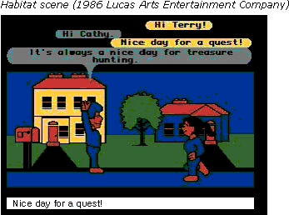

Habitat is said to have been inspired by Vernor Vinge's fantasy novel True Names. Habitat operated on the Commodore 64 and was a revolutionary program at the time as there was nothing else like it. As of 2001, we can see that the various functions sold at Sayclub or Freechal are embodying various objects that can be seen in the real world.

Habitat made a decisive contribution to the creation of the legendary online community, WorldsAway. WorldsAway evolved Habitat into a more sophisticated piece of software, as well as adding colorful graphics and enhancing the entertainment element. For example, by allowing a user to rotate their head 360 degrees, change the color of their face or body and even exchanging heads!
Glass City in Korea is based on the WorldsAway technology.

There were a lot of avatar images in WorldsAway. There were avatars such as animals, demons, and even fishbowls as well as human figures. The avatars each incorporated individuality and creativity, and the participants showed a passion to work on the design of their avatars, resulting in numerous WorldsAway-related homepages.

Now, Avatars have become a must for almost every online community. However, it should be noted that Avatars should not be regarded as a new means of making money. Increasingly, self-identity in a virtual society will include a state of mind as complex and delicate as self-identity in the real world.

